**MEDICAL INVENTORY OPTIMAZITION**

**Dataset Overview**

* **Rows :** 14218
* **Duplicates :** 26
* **Features :** 14
* **Categorical Columns :** 8 ("Typeofsales","Specialisation","Dept","Dateofbill","Formulation","DrugName","SubCat","SubCat1")
* **Continuous Columns :**6 ("Patient_ID","Quantity","ReturnQuantity","Final_Cost","Final_Sales","RtnMRP")

**Correlation Chart**

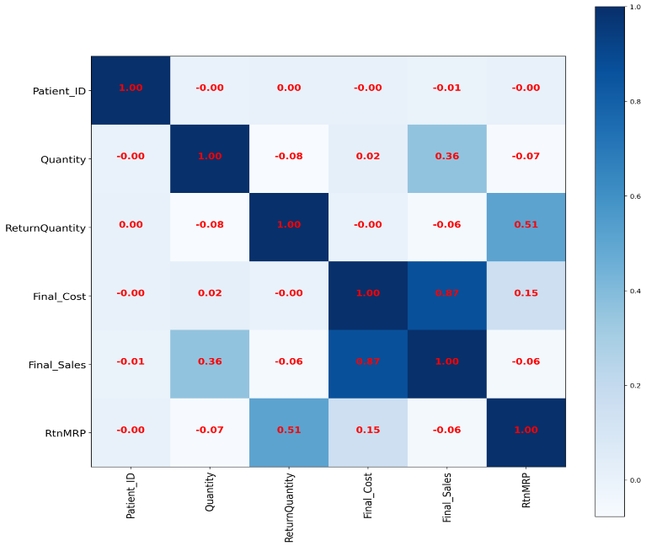

**Missing Values Distribution**

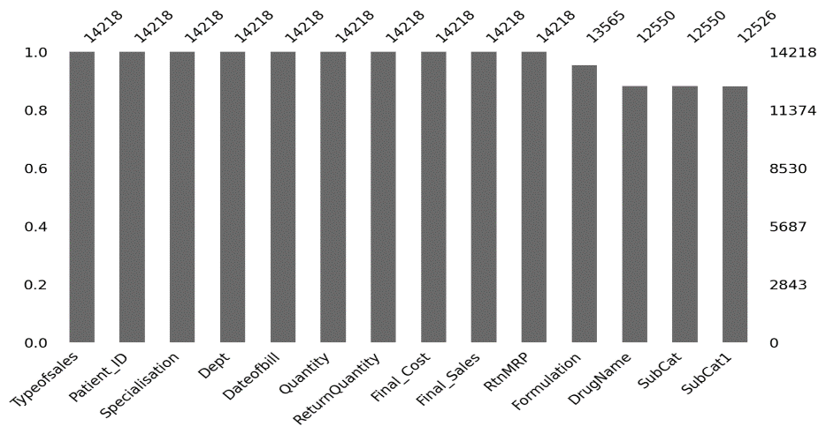

**Understand Continuous FeatureQuantityCount :** 14218.0**Mean :** 2.23**Standard Deviation :** 5.13**Maximum :** 150.0

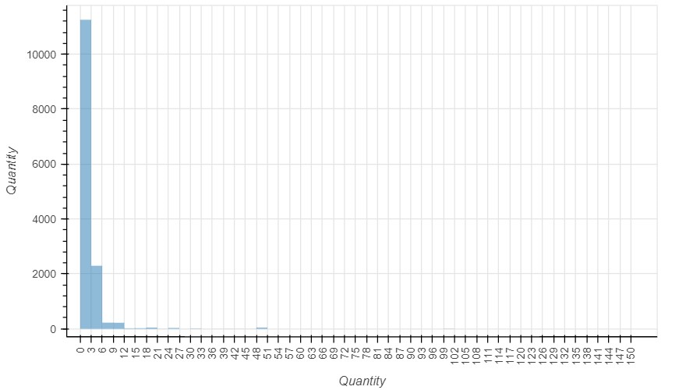

**Understand Categorical Feature**

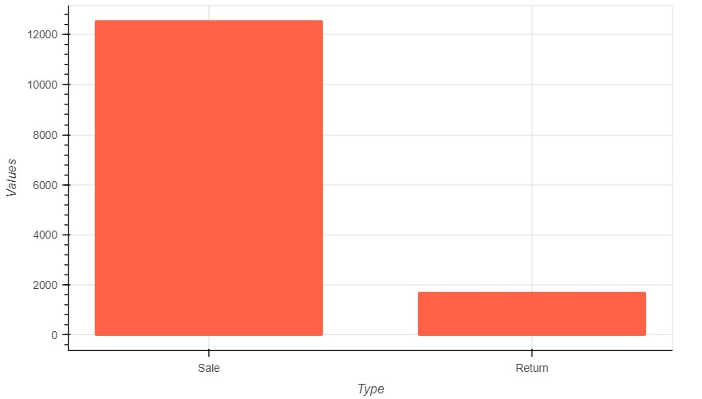

**Explore Relationship Between Features of DatasetX-Axis:**  Quantity**Y-Axis:** Final_Sales

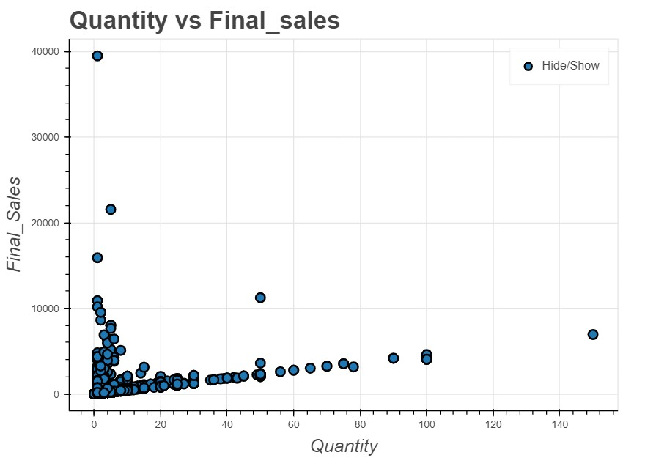

**OVERVIEW**

Medical Inventory Optimization dataset comprises 14,218 rows and 14 features, encompassing both categorical and continuous variables. Notably, there are 26 duplicate rows in the dataset. Among the 14 features, 8 are categorical, providing information on aspects such as sales type, specialization, department, date of bill, formulation, drug name, and subcategories. Additionally, 6 features are continuous, including patient ID, quantity, return quantity, final cost, final sales, and return MRP. While you mentioned a correlation chart, specific correlation values, making it unclear which variables are strongly related. I've highlighted statistics for the continuous feature "Quantity," indicating a mean of 2.23, a standard deviation of 5.13, and a maximum value of 150.0. I focus seems to be on understanding the relationship between Quantity (X-axis) and Final Sales (Y-axis), likely to inform inventory optimization strategies. To achieve this, you should undertake data preprocessing, exploratory data analysis, potential feature engineering, model development, evaluation, and deployment to tailor your inventory management to your organization's goals and constraints effectively.

**THANK YOU…**